**Open Source Graphics And Animation tools**

**Practical File**

**(GIMP)**

*Submitted to*

**Dr.Durgansh Sharma**

**Associate Professor, Cybernetics SCS, UPES**

*Submitted By*

Name: Harsh Narain Mathur

Roll No.: 20

SAP ID: 500069098

B. Tech CSE (OSSOS)Department of Cybernetics

COMPUTER SCIENCE & ENGINEERING

cid:1511675710.3638.14.camel@ddn.upes.ac.in

**School of Computer Science**

**University of Petroleum and Energy Studies,**

**Dehradun – 248007: Uttarakhand**

**January 2020**

Contents

EXPERIMENT-1 1

AIM: DRAW A CARTOON CHARACTER OF OUR CHOICE 1

EXPERIMENT-2 1

AIM:Write all the 6 words. 1

EXPERIMENT-3 1

AIM:DESIGN A LOGO OF UPES 1

Experiment-4 1

AIM:Create a logo of Google 1

# EXPERIMENT-1

## AIM: DRAW A CARTOON CHARACTER OF OUR CHOICE

Step 1 : Download your favourite cartoon character.

Step 2 : Open the image in gimp 2.10

Step 3 : Create a layer above the image . Hide the created layer and select it.

Step 4 : Neatly trace the outline of the character.

Step 5 : using the fill bucket fill the respective colors.

Step 6 : Your Cartoon Character is ready . Save it.

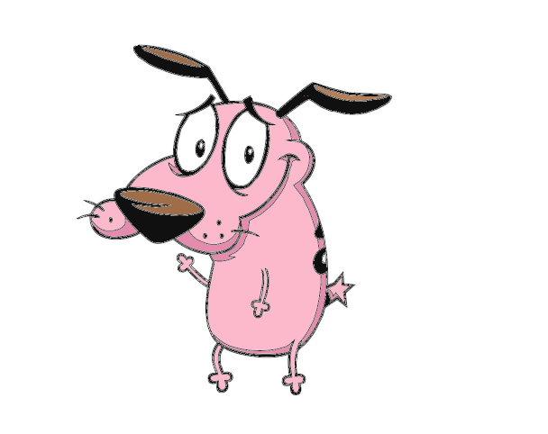

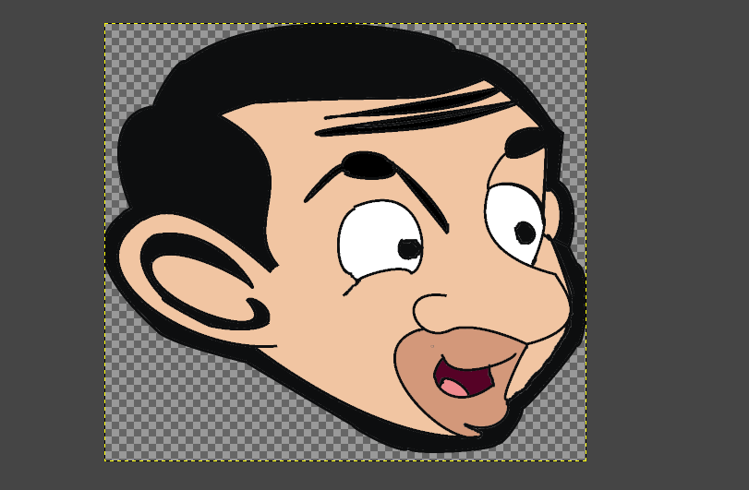

# EXPERIMENT-2

## AIM:Write all the 6 words.

Step-1:Open GIMP 2.10

Step-2:Create a new layer for it.

Step-3:Then open the image and trace it down in it.

Step-4:Stroke the path and fill it with the bucket color.

Step-5:All the displayed words will be ready.

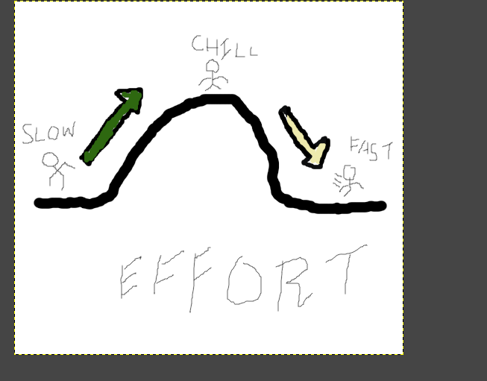

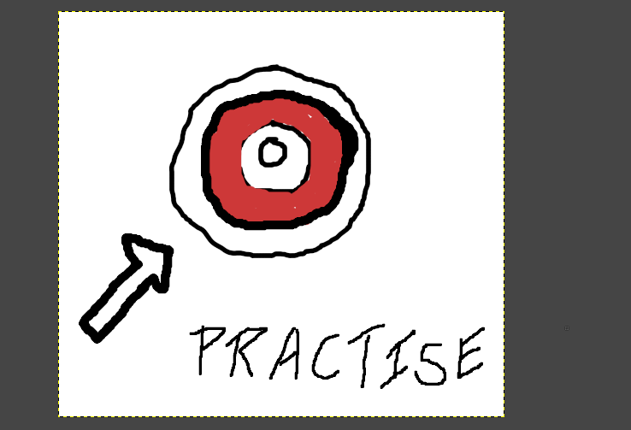

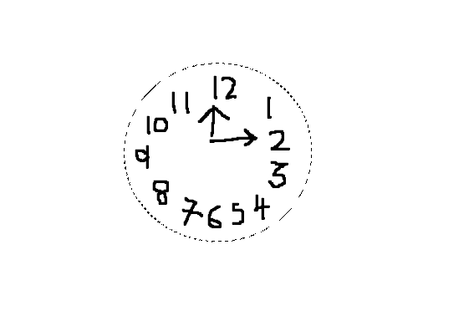

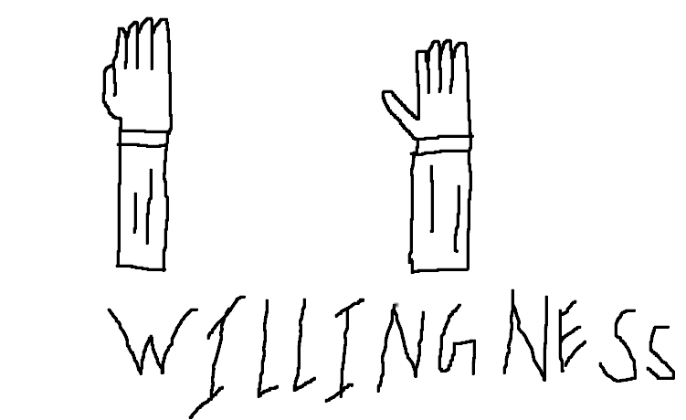



# EXPERIMENT-3

AIM:DESIGN A LOGO OF UPES.

Step-1:First,create a new from the file menu.

Step-2:Then go to select menu and create the grid

Step-3:Select the eclipse tool and form a cirlce by holding th shift key

Step-4:Fill that formed circle with the fill in with yellow color

Step-5:Make another circle little smaller from the earlier one and then delete the color from inside this circle.

Step-6:Now select the circle as a path(so we could write down the quote along path).

Step-7:Now write the text using the text box and select the layer and right click on it and select text along path.

Step-8:Now use the path tool to trace for the logo initials('u' in this case)

Step-9:Now fill this with the fill in color with red and yellow.

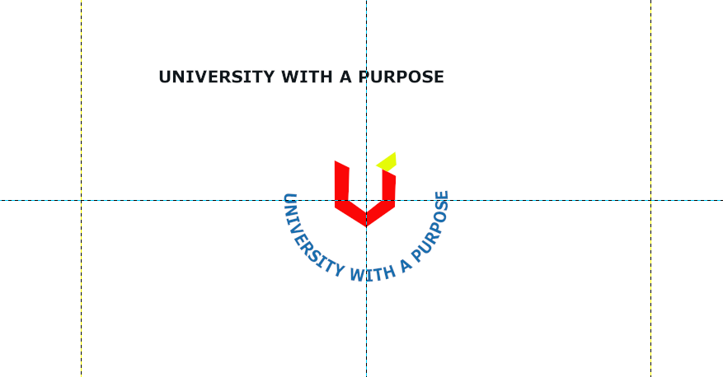

# Experiment-4

## AIM:Create a logo of Google

Step 1 : Download Google image.

Step 2 : Open the image in gimp 2.10

Step 3 : Create a layer above the image . Hide the created layer and select it.

Step 4 : Neatly trace the outline of the character.

Step 5 : using the fill bucket fill the respective colors.

Step 6 : Your logo is ready . Save it.

